Accountant User Guide — QtrShoe Delivery App

Overview
Main functions:
- Review driver collections
- Monitor balances
- Record deposits
- Review invoices
- Track returned / failed orders

Dashboard Summary (Top Cards)
The top cards display totals for the selected period:
- Order Value: Total value of all processed orders.
- Delivered: Total value of successfully completed orders.
- Returned: Total value of rejected or returned orders.
- Cash Collected: Cash received by drivers from customers.
- Bank Received: Customer payments transferred directly to the company bank account.
- Cash Fees: Delivery fees kept by drivers from cash orders.
- Bank Fees: Delivery fees owed to drivers from bank-paid orders.
- Owed To Drivers: The amount of money owed to drivers that has not been paid yet.
- Payouts: Amounts paid by the company to drivers.
- Cash Refunds: Refunds paid by drivers during item pickup.
- Deposited: Amount already received and recorded by accounting.
- Outstanding: Current balance between driver and company (cash still with the driver, or cash owed back to the driver).

Outstanding Examples
QAR 4,200 → Driver must pay the company
- QAR 5,500 → Company must pay the driver
OK → No balance due

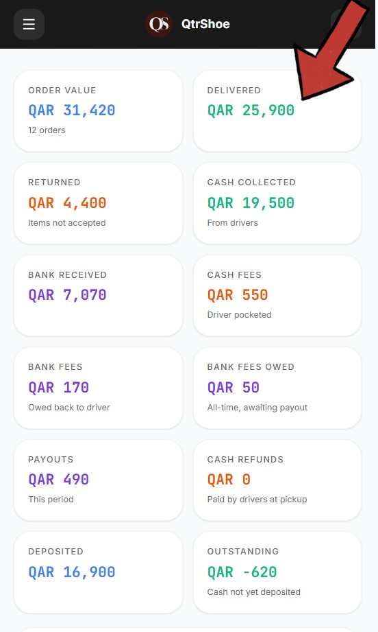

Date filters
Use filters to view specific periods.
Quick filters:
- Today
- Yesterday
- Last Week
- Last Month
Custom range:
- From → To (select any date range)

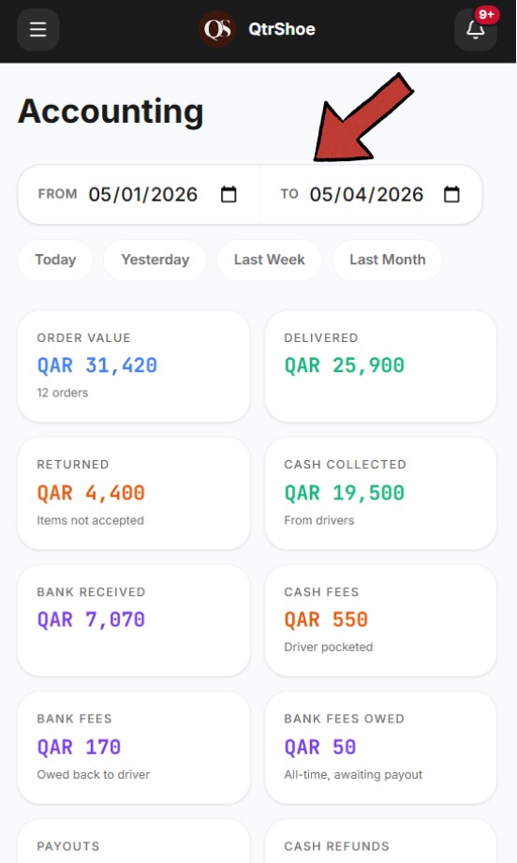

Collections
Displays each driver’s financial summary, including:
- Orders (number of deliveries)
- Delivered (completed delivery value)
- Returned (returned or rejected order value)
- Cash (cash collected from customers)
- Bank (bank transfer payments)
- Cash Fees (delivery fees kept by the driver from cash orders)
- Refunds (refund amounts related to returned or rejected orders)
- Deposited (already submitted and recorded)
- Outstanding (remaining balance between driver and company)
- Actions:( when you Click Collect means that you have received the Cash from The
Driver. OK means the account is clear, the driver has no balance due or receivable)
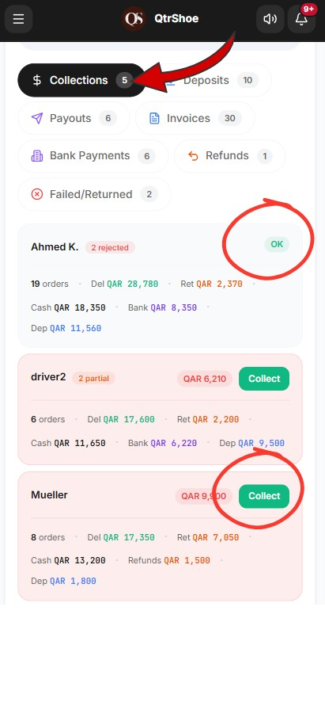

Notifications
The system sends accounting alerts.
Example: Cash to Collect Includes:
- Driver name
- Order number

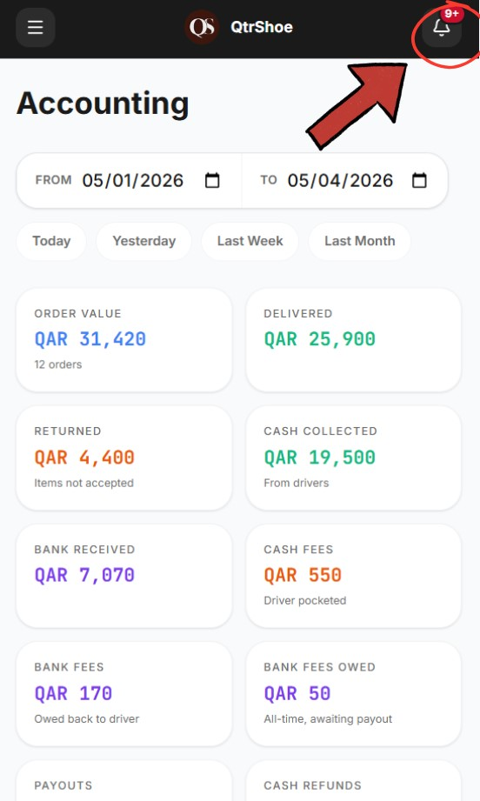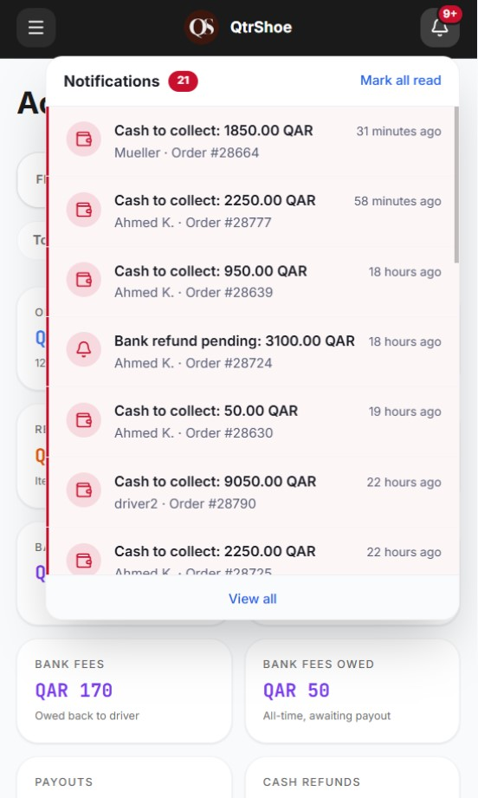

Deposits
Displays all recorded deposit transactions submitted by drivers or entered by finance.
The accountant can review:
- Date: Deposit record date
- Driver: Driver associated with the deposit
- Amount: Recorded deposit value
- Type: Deposit method o Cash to Accountant: Cash physically handed to finance o Bank Deposit: Bank transfer confirmed by accounting o Adjustment: Manual balance correction / settlement adjustment
- Reference: Bank reference number (if available)
- Recorded By: User who logged the deposit
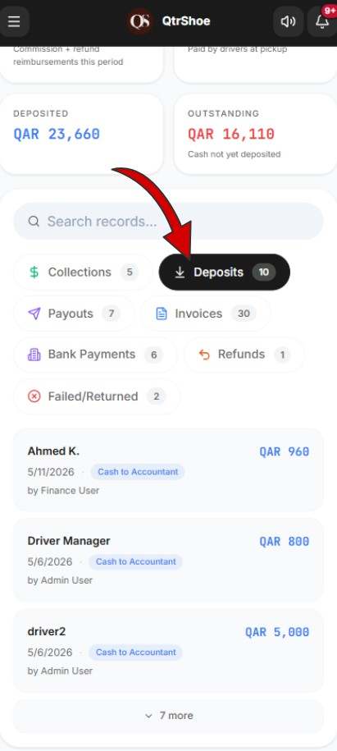

Payouts
Displays each driver’s payout summary for the selected period.
Shows:
- Total completed orders
- Cash collected
- Bank payments
- Delivery fees earned
- Total already paid
Pay QAR XXX means this delivery fee amount is owed to the driver, usually from orders paid by bank transfer where the company received the payment.
Settled means the driver has already been fully paid.
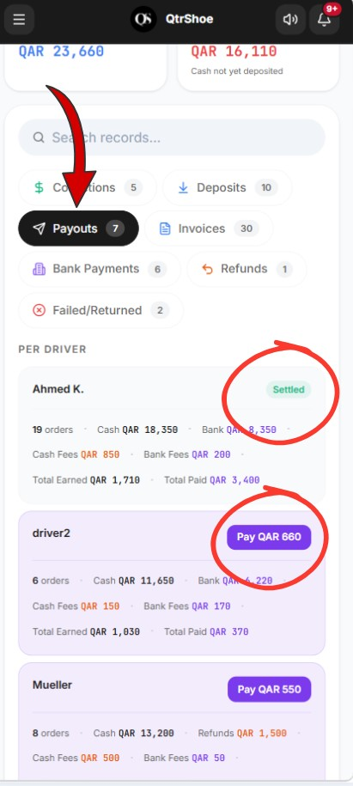

To pay the driver, just click “PAY QAR xxx”, then select the driver’s name and enter the amount, then press “Confirm”.

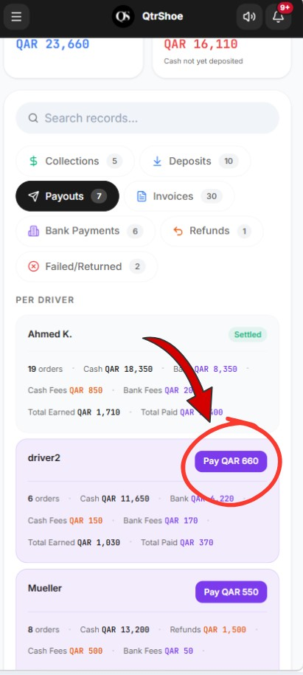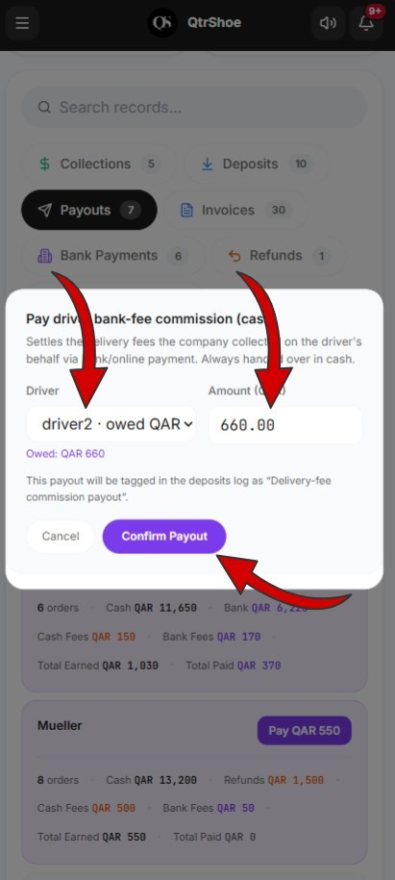

Invoices
Invoices are generated automatically.
- Action available: Download PDF
- Invoices cannot be edited.

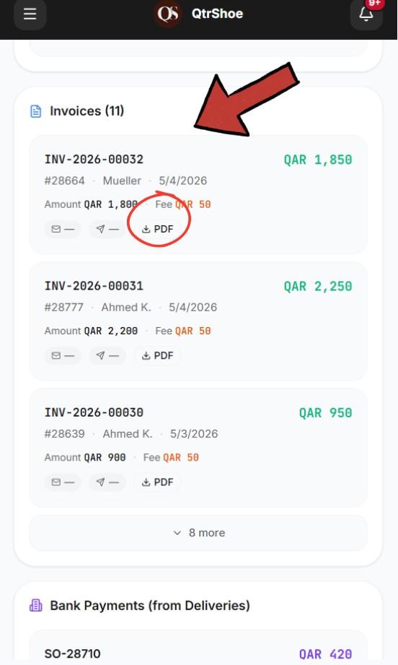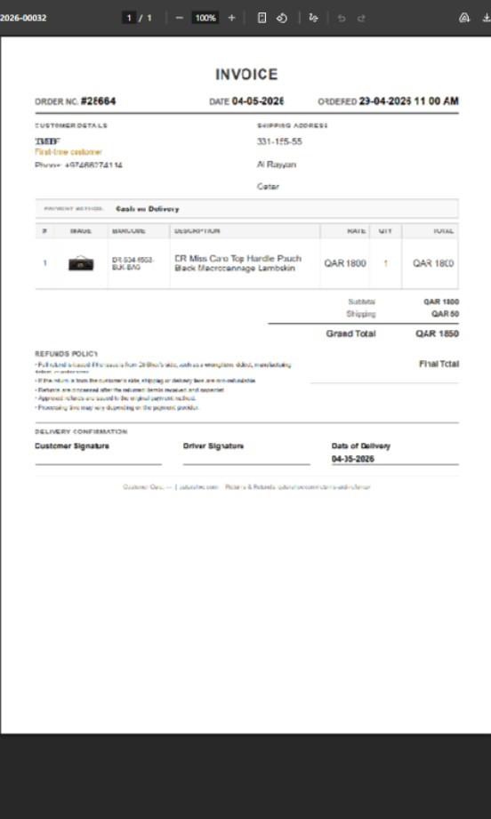

Bank payments
Shows customer payments made through bank transfer, including:
- Order number
- Amount
- Payment type
- Screenshot / proof

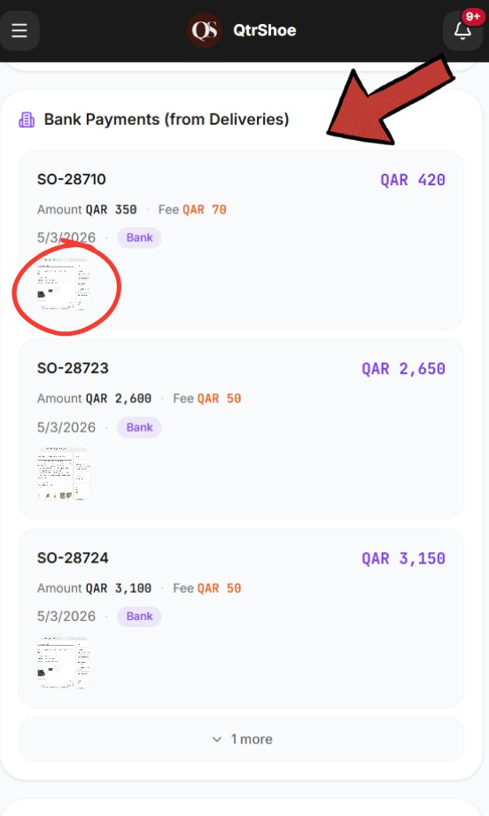

Refunds
Shows refund amounts paid by drivers during pickups or return-related deliveries.
Displays:
- Order number
- Customer name
- Driver name
- Refund amount
- Refund date
These amounts are tracked so they can be included in driver financial calculations and reimbursement records.

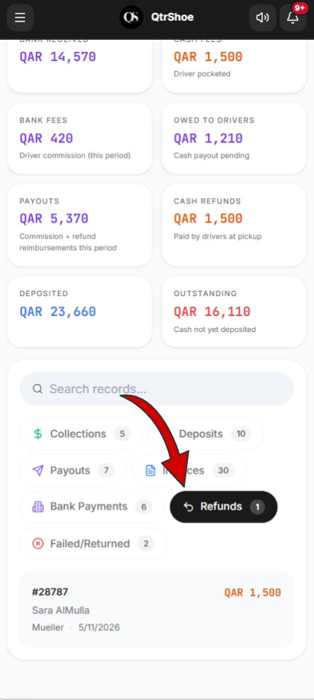

Failed / returned orders
Displays delivery issues, including:
- Order number
- Customer
- Driver
- Status
- Reason
Financial effect:
- Cash orders: Driver keeps the delivery fee.
- Bank orders: Delivery fee affects the driver balance.

